**Kentucky Dairy Development Council’s**

**Beef on Dairy Initiative**

Program Guidelines and References

2023

Table of Contents

Why Beef on Dairy? 3

Kentucky Dairy Development Council’s Beef on Dairy Initiative 4

Participation Requirements and Parameters 4

Instructions for Participation and Cost Share Reimbursement 4

EPD Requirement 5

Beef on Dairy Producer Agreement and Self Certification Agreement 6

Incorporating Beef in a Dairy Herd 7

Maintaining Heifer Replacement Needs and Creating a Breeding Plan 7

Sire Selection 8

Marketing Beef on Dairy Calves 11

Calf Care 12

Colostrum Management 12

Refractometer 13

Health Protocols for Weaned Calves 14

Resources 15

Calf Birth Certificate 16

# Why Beef on Dairy?

Traditionally, dairy operations have focused primarily on- and excelled at- the production of one product: milk. Today, there are numerous opportunities for dairy producers to diversify and improve monetization of byproducts that are leaving the farm. Cull animals including bull calves and heifers that will not be retained have historically been considered byproducts on a dairy operation. However, strategically incorporating beef genetics in your herd can improve the marketability of those calves, provide an increased line of diversified income, decrease heifer raising costs, and decrease the environmental footprint of culls by producing an animal with improved feed efficiency.

While the use of beef semen on dairies has increased by over 20% in recent years and many companies and organizations have established beef on dairy programs, there are still obstacles to overcome. To create a sustainable program that fits the needs of your operation, you should carefully consider heifer replacement needs, sire selection, and marketing strategies for calves. Additionally, providing good calf care from birth is essential to address some of the concerns buyers have about dairy influenced cattle in feedlots, including a significantly higher rate of liver abscesses.

Beef on dairy may provide an improved stream of revenue for your operation over straight dairy animals with the proper planning and care. The Kentucky Dairy Development Council aims to address these considerations in our Beef on Dairy Initiative to support a sustainable beef on dairy market for Kentucky dairy producers.

# Kentucky Dairy Development Council’s Beef on Dairy Initiative

## Participation Requirements and Parameters

* DHIA or equivalent qualified management program
* Permitted Kentucky dairy farm
* Verification of herd size
* Beef semen
  + Obtained from qualified KDDC listing
  + Limit of 2 straws of semen per eligible cow
  + Maximum number of cows eligible is 40% of cows represented on DHIA or equivalent management program
  + Cost share of 50% with max $15 KDDC contribution per straw
* Beef herd bull
  + Genomic tested and meets KDDC EPD requirements (page 4)
  + Limited to one bull per herd
  + Cost share of 50% with max $2,500 KDDC contribution per bull
* Program tags for calves
  + Sire qualified for KDDC Beef on Dairy Initiative cost share program
  + Beef on Dairy Proficiency Certified

## Instructions for Participation and Cost Share Reimbursement

* Complete a Beef on Dairy Producer Agreement and Self Certification Agreement form
* Semen invoices must include sire information, cost per straw, number of straws purchased and date of purchase.
* Herd bull invoices must include genetic information, date of purchase and purchase price. If purchased without genetic in’formation you must genomic test to acquire necessary EPD information at your expense.
* Submit Agreement form and invoices through your consultant or to: Jennifer Hickerson, PO Box 293, Flemingsburg, KY 41041 or email [j.hickersonkddc@gmail.com](mailto:j.hickersonkddc@gmail.com).

## EPD Requirement

Any bull that is associated with and approved through an AI company’s individual beef on dairy program qualifies. Sires that are not included in an existing program, including herd bulls, must be genomically tested and meet the criteria below. These criteria were selected in conjunction with University of Kentucky’s Beef Extension based on data that supports the production of a terminal crossbred calf with competitive carcass traits. As data expands, these requirements may be adjusted.

To maximize success, consider more specific EPD selection based on your situation. For example, higher CED values should be considered for bulls covering heifers and higher YW values will allow for more balance to the slower growth rate of dairy animals.

|  |  |  |  |  |  |  |  |
| --- | --- | --- | --- | --- | --- | --- | --- |
|  |  | CED (>=) | YW (>) | CW (<=) | MARB (>=) | REA (>=) | $Ax_ (>=) |
| Holstein | Angus | 3 | - | - | - | - | 98 (40%) |
| Red Angus | 11 | 104 (40%) | 31 (75%) | - | .25 (25%) | - |
| Limousin | 9 | 104 (40%) | 31 (65%) | -.08 (50%) | .91 (50%) | - |
| Simmental | 7 | 104 (75%) | 31 (60%) | -.08 (90%) | .91 (40%) | - |
| Jersey | Angus | 3 | - | - | - | - | 80 (40%) |
| Red Angus | 11 | 115 (20%) | - | - | .25 (25%) | - |
| Limousin | 9 | 115 (20%) | - | -.08 (50%) | .91 (50%) | - |
| Simmental | 9 | 115 (50%) | - | -.08 (90%) | .91 (40%) | - |

*For Simmental, API of >=133 (40%) should be used over YW, CW, MARB, and REA when available.

**Definitions**

**EPD** (Expected Progeny Difference) more on page 9

**CED** (Calving Ease Direct), difference in percentage of unassisted births, with a higher value indicating greater calving ease in first-calf heifers.

**$AxH** (Angus-On-Holstein), **$AxJ** (Angus-On-Jersey) a terminal index to predict profitability differences in dollars per head of crossbred progeny. Assumes calves will be fed and marketed on a quality- based grid. Traits included are calving ease, growth from birth through the feeding phase, feed intake, dressing percent, yield grade, quality grade, muscling, and height.

**CW** (Carcass Weight) predicts differences in hot carcass weight and is expressed in pounds.

**YW** (Yearling Weight) predicts difference, in pounds, for yearling weight.

**MARB** (Marbling Score) predicts differences for carcass marbling score in marbling score units.

**REA** (Rib Eye Area) predicts differences of carcass Rib Eye Area between the 12th and 13th rib. Increased REA has a beneficial effect on Yield Grade which also includes CW and Fat Thickness.

**API** (All-Purpose Index) evaluates sires for use on the entire cow herd with a portion of their daughters retained and the remaining heifers and steers put on feed and sold grade and yield.

## Beef on Dairy Producer Agreement and Self Certification Agreement

I have read and understand the qualifying standards to participate in the Beef on Dairy Program. I give KDDC permission to access information for Beef on Dairy. I agree to the requirements to participate in the KDDC Beef on Dairy Program and will allow or provide access to records produced during the eligible period by KDDC Consultants.

Producer # _____________________ Division # _________________________

Permit Holder: _________________________________________________________________

Marketing Agency: ______________________________________________________________

Phone Contact: _________________________ Email: _______________________________

Mailing Address: __________________________________________

__________________________________________

__________________________________________

__________________________________________

DHIA Herd Code: __________________________________________

DHIA RAC Code: ___________________________________________

I certify that my milking herd consist of ____________ number of cows.

___________ Producer Initial here

**Self certification is subject to possible spot check verification to ensure integrity of program. DHIA records or herd management records may be requested.

KDDC Representative _______________________________________

Producer Signature _________________________________________

Date ___________________

**KDDC USE ONLY**

Number of qualifying units of semen: ____________

# Incorporating Beef in a Dairy Herd

Before using beef genetics in a dairy herd, consider heifer replacement needs, breeding plans, sire selection, and how beef on dairy calves will be marketed.

## Maintaining Heifer Replacement Needs and Creating a Breeding Plan

One benefit of using beef bulls is to reduce the cost of raising an excessive number of calves. Heifer raising costs is the second greatest cost on a dairy farm, behind crop enterprises, so understanding this cost, replacement needs, and maximizing the potential of beef genetics on a dairy are all essential pieces of a successful beef on dairy program.

Heifer inventory should be evaluated to assess needs. Consulting with your reproductive advisor and following the steps below can help you determine how many heifers are needed.

Mandy Schmidt, Genetic Data Analysis Consultant with ABS / Grai-Rose Cattle Sales & Marketing, for Progressive Dairy, February 22, 2019

When evaluating replacement needs, the breeding plan for the herd needs to be considered. Are cows bred by artificial insemination or with a herd bull? Is sexed semen used? These factors influence heifer numbers and the ways that beef can be used in a herd. Using AI to breed cows allows a herd more flexibility in the sires used, including high genetic merit bulls and beef bulls, and has many other economically relevant advantages.

Sexed semen has the potential to improve the speed of genetic improvement in a herd, especially when combined with genomic testing. Using genomic testing to determine the genetic potential of the animals in your herd can help you chose the best candidates for sexed, conventional, and beef semen. Refer to the KDDC MILK 4.0 Program Manual for more information on genomic testing and cost share opportunities.

A basic example of breeding program using conventional, sexed, and beef semen is represented in the graph below. Genomic testing is an efficient way to rank females by quality. The lowest quality females are bred to beef semen, average cows are bred conventionally, and highest quality cows are bred to sexed semen. By focusing on higher end animals for replacements, the average quality of a herd- represented by the star- can improve at a faster rate than relying on conventional semen alone.

The University of Wisconsin-Madison has developed a decision-making tool where producers can conduct an in-depth analysis of profitability of beef usage on their dairy farm. This is also helpful to determine the number of replacement heifers needed to maintain herd numbers when using beef semen. Available at: <https://livestock.extension.wisc.edu/files/2020/11/The_Premium_Beef_on_Dairy_Program.pdf>.

## Sire Selection

Selecting beef bulls with traits that work well with dairy genetics is an important step in creating a successful, long-term beef on dairy program. The following publication from the University of Wisconsin-Madison discusses important considerations for selecting beef sires that will produce a reliable beef on dairy calf.





## Marketing Beef on Dairy Calves

Deciding how calves will be marketed before breeding can be the key to creating a successful beef on dairy program. Specific factors to consider include deciding if they will meet the requirements of an established beef on dairy marketing program, what age/weight they will be marketed at, and the marketing methods.

With the rise in usage of beef semen in dairy herds, organizations and companies have developed marketing programs focused on producing high quality calves to improve the sustainability of beef on dairy in the marketplace. Currently, several AI companies and breed organizations have well-established beef on dairy programs. These programs rely on data from sires that are selected for traits that complement dairy genetics and are proven to produce efficient, high-quality calves. Similarly, KDDC’s Beef on Dairy Initiative ensures sires meet certain EPD criteria and encourages good calf care to create an animal that buyers can rely on. Program ear tags are commonly used to identify calves when being marketed and improve traceability.

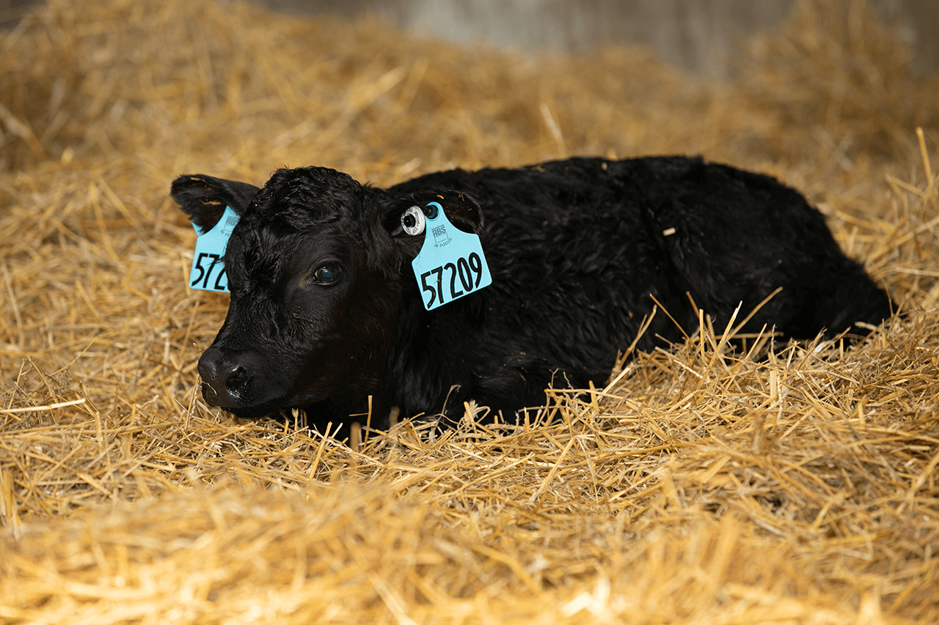 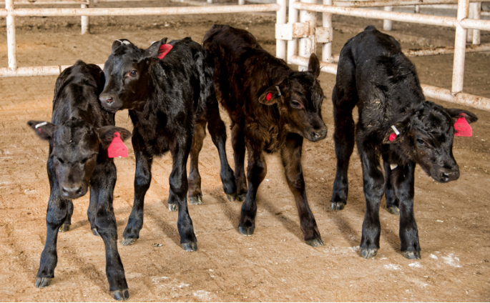

Ear tags like these from ABS (left) and Select Sires (right) make it easy to identify calves that are part of an established program.

A significant advantage for dairy herds producing program calves is the ability to make connections with buyers that select calves from a specific program. Buyers may select for certain programs because of preferences for certain carcass and growth traits, as well as general reliability and uniformity of calves sourced from similar genetics.

Whether raising calves in or independent of a program, connecting with a buyer or using marketing services can help you make other determinations, including age/weight that calves should be sold, if they will be sold directly off the farm or through a sale facility, and price expectations. Making contacts prior to breeding for beef on dairy calves and meeting the genetic needs of your buyer can make a significant difference in profitability and marketability of calves. Your AI representative, local stockyards, calf growers, and your KDDC consultant can all be beneficial advisors when discussing marketing options to find the best fit for your operation.

# Calf Care

The calf care procedures should be the same for beef on dairy calves as they are for calves intended for replacements in the milking herd. One of the primary weaknesses of beef on dairy crosses at the feeder stage is health issues including liver abscesses, but with a strong beginning and good calf care basics, these issues later in life can be minimized.

The calf care basics to focus on include a clean birthing area and calf housing, adequate feed and water supplementation during the milk-feeding phase, and- most importantly- good colostrum management and intake at birth.

## Colostrum Management

To achieve passive transfer, a 90-pound calf should be fed a minimum of 100 g of IgG in the first feeding of colostrum. However, because producers frequently do not know the concentration of IgG in the colostrum being fed, it is currently recommended calves be fed 10% to 12% of their body weight in colostrum at first feeding. This means the calf should be fed three to four quarts of colostrum at birth and an additional two quarts by 12 hours after birth. Research has shown calves fed four quarts of colostrum at birth and two quarts 12 hours later have higher blood serum IgG levels at 24 hours of life. The calf should be hand-fed a known volume of colostrum using either a nipple bottle or an esophageal feeder to guarantee enough colostrum is consumed.

To determine the concentration of IgG in the colostrum, a colostrometer (graduated cylinder hydrometer) or a Brix refractometer can be used. While both methods are effective ways to test colostrum quality, advantages of the refractometer include more accuracy independent of temperature of colostrum and less colostrum needed for the test. Below are guidelines on using a refractometer to test colostrum. Contact your KDDC consultant about opportunities to receive a refractometer.

### Refractometer

*Calibrate to “0” using distilled water on the main prim to maintain accuracy.

Understanding readings: Greater than 22% Brix value colostrum is considered high quality.

Colostrum can be fed or frozen in a sterile jug or bag, to be thawed as needed in water between 120-140° F. Labeling the jug or bag with quality, quantity, and date can help keep colostrum inventory organized.

Less than 22% Brix value colostrum is considered poor quality.

If this colostrum must be fed, it should be fed in addition to a quality colostrum supplement or replacer, following the feeding directions on the product label.

## Health Protocols for Weaned Calves

The following protocols are recommended when selling weaned calves. When selling wet and pre-weaned calves, work with your veterinarian to establish a protocol that will establish a healthy start, including adequate colostrum intake and a vaccination schedule.

* Hold calves for a minimum of 45 days after weaning
* Trained to eat from a bunk and drink from troughs
* Dehorned and healed
* Castrated and healed (knife castration strongly recommended)
* Treated for grubs and lice (according to seasonal recommendations)
* Dewormed with endectocide a maximum of 60 days prior to the sale
* Vaccinated for Clostridia (7-way or 8-way) according to manufacturers label instructions
* Vaccinated and boostered for IBR, BVD, PI3 and BRSV. Booster injection must be modified live
* Vaccinated for Mannheimia haemolytica toxoid (“Pasteurella”)
* Access to a free choice mineral supplement that meets nutritional needs

# Resources

Visit KDDC’s online library at kydairy.org for more information regarding beef on dairy. This website is constantly updating and includes:

Calf Birth Certificate (English and Spanish)

*Colostrum Management for Dairy Calves*, Dr. Michelle Arnold, University of Kentucky

*How Many Dairy Replacements Do You Need to Raise to Maintain Your Dairy’s Herd Size?,* Donna Amaral-Phillips UK Dairy Extension

*Feeding the Newborn Calf*, Written by Jackie MCCARVILLE, Heather Schlesser and ASHLEY A OLSON https://livestock.extension.wisc.edu/articles/feeding-the-newborn-calf/

## Calf Birth Certificate

